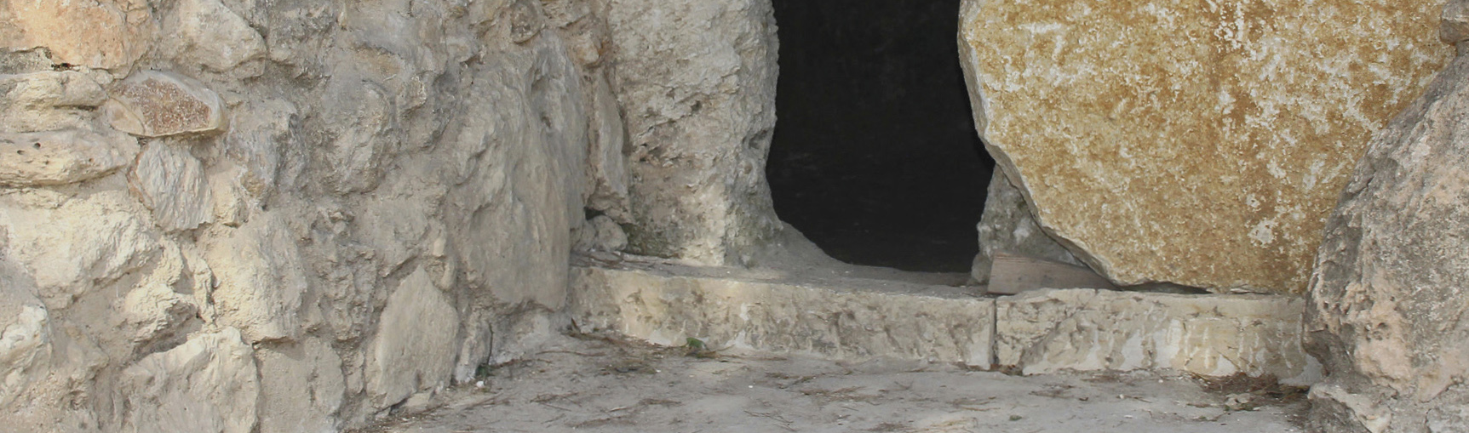

MEMORIZATION GUIDELINES

The following guidelines are for the 2019-2020 Bible Quiz season over the Gospel of John.

The Memorization Award is available to quizzers, grades 6-12, and to all Bible Quiz coaches and officials. The Memorization Award rules and guidelines apply to all participants (quizzers, coaches, and officials) who are working on their 2019-2020 National Memorization Award.

The coach or official to whom the quizzer quotes must not be a parent or family member. If the coach or official is a parent or family member of the quizzer, the quizzer must quote to another coach or official in the church. In the event that the parent or family member is the only Bible Quiz coach or official in the church, the quizzer may quote to their youth pastor, youth sponsor, senior pastor, league coordinator, district coordinator, or another adult who has a firm understanding of the quoting rules.

All quizzers must quote an entire chapter at one sitting, starting at the first verse quoting each verse in order to the end of the chapter, to a Bible Quiz coach or official.

The quizzer is permitted four mistakes per chapter. Each word that is omitted, repeated, added, or changed counts as one mistake. If a quizzer corrects himself or herself, the correction still counts as a mistake.

The quizzer may quote the entire chapter as many times as necessary to quote within the four-mistake limit.

Each quizzer must quote at least one entire chapter during a Sunday morning, Sunday evening, or Wednesday evening service, small groups, etc. in their local church. The chapter may have been previously quoted to a coach (youth pastor, etc) so that the number of mistakes in the pulpit (public setting) will not hinder their award. Coaches should set the service date with the senior pastor on the church calendar early in 2019-2020 quiz season.

Quizzers in grades 6 through 12 who compete in the "A" division during the 2019-2020 quiz season must quote the entirety of the Gospel of John. Quizzers in grades 6 through 8 who compete in the “Middle School” division are required to quote John chapters 1-6 and 19-21. Quizzers in grades 6 through 12 who are competing in the “XP5” division are only required to
quote John chapters 1, 3, 4, and 19. However, “Middle School”; and “XP5” may also quote the entire “A” league material
if they so desire.

Only students who complete the "A" League Memorization Award, covering all of the Gospel of John will be eligible for any
Bible Quiz Memorization Award scholarships offered through many Assemblies of God colleges and universities. Students who earn the Middle School, or XP5 Memorization Award will NOT be eligible for scholarships from the district office, national youth ministries or from any Assembly of God college or university (unless specified by that college or university).

DBQC to turn in all names by Friday, April 24, 2020.

